SOLUTIONS PART 1
APPLICATIONS

Question 1
(a) | 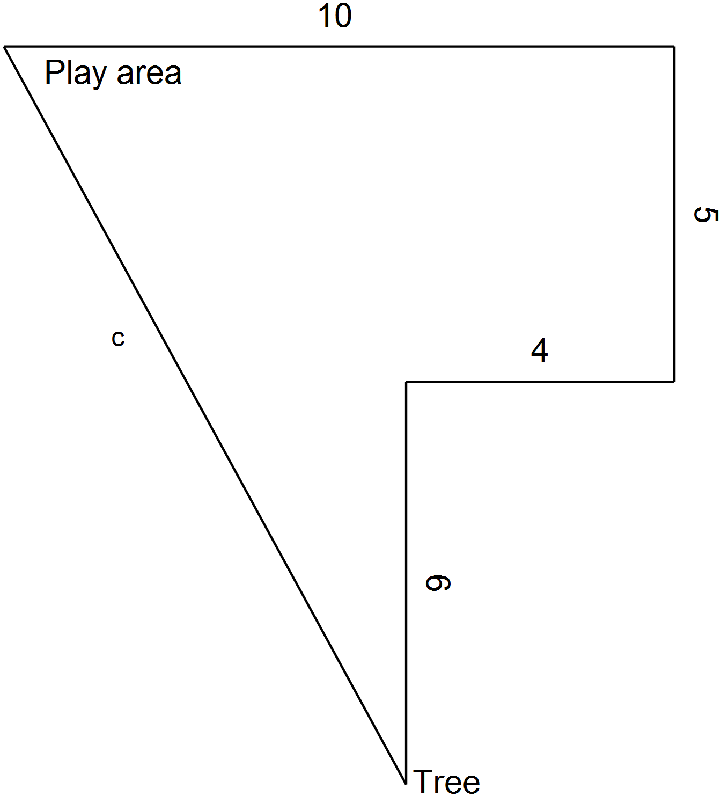 | (b) | 12.6 m
 |  | (c)
 |  | (d) | (i) Pythagoras. The measured distance is more likely to contain user error as it is measured rather than calculated.  (ii) 0.1 m  (iii) 0.56%

Question 2
(a) | For the top of the kite  For the bottom of the kite  Perimeter = | (b)  (c)  (d) | 687+ 4 × 10=727 cm  727 m  Area = 2 × 0.5 × 300 × 80  =24 000 cm²

Question 3
(a) | Straw inside cylinder  Then add 10 and round | (b) | First find the diagonal of the base  Now the diagonal of the box  Add 10 and round  Straw is 25 cm

Question 4
(a) | Distance of stake from tree
(b) | 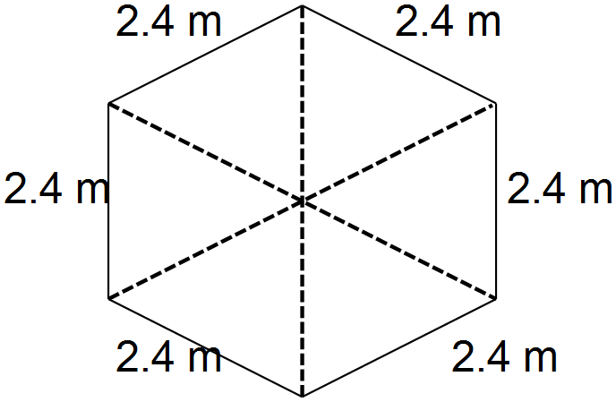 From above the tree is in the centre of a  regular hexagon with angles of 60º at the centre.  The stakes are equidistant from the centre  so the triangles have equal base angles  so the hexagonal base is made up of equilateral triangles with sides of 2.4 m.
(c) | For the netting, first find the height of the sides of the hexagonal pyramid..  Each side is an isosceles triangle; the line drawn from the vertex and perpendicular to the base represents the height. This line divides the triangle into 2 congruent triangles so meets the base at the mid-point. A right-angled triangle with base 1.2 m (half of 2.4) and hypotenuse 3 is formed.

Question 5
(a) | Goal mouth = 40.32-11-11-11=7.32 m | (c) | (iii)
(b) | 16.5 – 5.5 = 11 m
(c) | (i)  (ii)

Question 6
(a)  (b) | 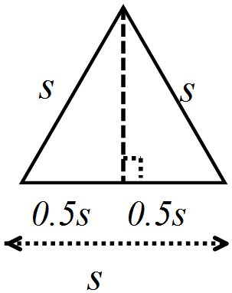 | (c)
 |  | (d)

